Ref. No. MES IMCC / 172/ 2025 – 26/ Date:

CERTIFICATE

This is to certify that the Project entitled “MonthVest” is completed by “Tejaswini Patil & Shrushti Mangalekar” of S.Y. M.C.A. Semester I for the Academic Year 2025-26 at MES’ Institute of Management & Career Courses (IMCC), Pune - 411038.

To the best of our knowledge, this is an original study done by the said student and important sources used by her have been duly acknowledged in this report.

The report is submitted as a part of course ITP31 Mini Project for the Academic Year 202526 as per the rules and guidelines prescribed by the institute.

Ms. Minakshi More Ms. Manasi Shirurkar Dr. Ravikant Zirmite Project Coordinator Program Coordinator Head, Dept. Of MCA

Index

1. Project Scope

1.1 Title

1.2 Overview

1.3 Tech Stack

1.4 Data Schema

2. UML Diagrams

2.1 ERD

2.2 Use Case Diagram

2.3 Data Dictionary

3. User Interface
3.1 Home Page
3.2 Registration Page
3.3 Login Page
3.4 Dashboard Page
3.5 Add Investment Page
3.6 Edit / Delete Investment Page
3.7 Monthly Performance Page
3.8 User Profile Page

1.Project Scope

1.1 Title
MonthVest – Smart Monthly Investment Analyzer
Overview:
MonthVest – Smart Monthly Investment Analyzer is a web-based personal investment management system designed to help users efficiently track and analyze their financial investments. The platform enables users to record investment details across various instruments such as Gold, Stocks, Mutual Funds, and Fixed Deposits in a single centralized system.
It provides an organized dashboard to monitor total investments, returns, and profit or loss, while offering monthly performance insights and category-wise investment distribution. The system also delivers personalized investment suggestions based on user categories such as Student, Adult, Senior Citizen, and Women, supporting informed and structured financial planning.
Project Objectives:
- Centralized investment tracking
- Automated calculation of returns
- Category-wise investment analysis
- Monthly performance insights
- User-specific investment insights
- Secure data storage and access
User Roles & Responsibilities
- Account Security & Integrity
- Accurate Investment Data Entry
- Portfolio Monitoring &Updates
- Responsible of Investment Suggestions
- Compliance with System Guidelines

Core Features:
1. Authentication & User Profiles
o Secure user registration and login
o Personalized user profiles with category selection
2. Investment Management System
o Add, edit, and delete investments
o Support for multiple investment types (Stocks, Mutual Funds, FD)
3. Intelligent Dashboard
o Automated calculation of:
▪ Total invested amount
▪ Current value
▪ Profit / Loss
o Visual representation using charts and summaries
4. Category-Wise Investment Analysis
o Smart categorization of investments
o Clear distribution of funds across investment categories
5. Monthly Performance Tracking
o Month-wise profit and loss insights
o Identification of best and low-performing investment categories
6. Personalized Investment Suggestions
o Recommendations based on user category:
▪ Student
▪ Adult
▪ Senior Citizen
▪ Women
o Helps optimize investment strategy and returns
7. Reports & Data Insights
o Summary reports of investment performance
o Downloadable data for future reference

Technology Stack:
- Frontend:

- HTML5: Structures the dashboard, sidebar, and chart sections.
- CSS3: Styles the layout and adds responsive design and effects.
- JavaScript (Vanilla JS): Handles dynamic content, calculations, and DOM updates.
- Chart.js: Displays interactive charts for investments.
- Font Awesome: Provides icons for sidebar and UI elements.

- Backend:
- Python: Runtime language for backend logic, calculations, and data processing.
- Flask: Framework to handle API routes, HTTP requests, and business logic.
- Yahoo Finance API: Used to fetch real-time stock and market data for portfolio updates.
.
- Database:
- SQLite: Relational database to store users, investment records, and transaction history.

- Tools:
- Postman: For testing and debugging APIs (including Yahoo Finance endpoints).
- Git/GitHub: For version control and project management.

Database Schema Overview:
The application utilizes a relational database schema implemented in SQLite. The schema is designed to separate user authentication data from investment data while maintaining referential integrity through proper foreign key relationships.

Table: user
- Purpose: Stores registered user credentials and profile information, including name, email, and user category (Student, Adult, Senior Citizen, Women) for authentication and personalization.

Table: investment
- Purpose: Stores all investment records for users, including investment type (Stocks, Mutual Funds, FD), invested amount, current value, duration, and start date.

Table: category
- Purpose: Stores investment categories and metadata to classify investments and enable category-wise analysis.

Table: transaction_history
- Purpose: Maintains a record of all investment transactions for a user, enabling tracking of profits, losses, and monthly trends.
Relationships: Each user can have multiple investments (1-to-many relationship). Each investment belongs to a category (many-to-1 relationship). Transaction history is linked to user and investment for detailed tracking.

- UML Diagram
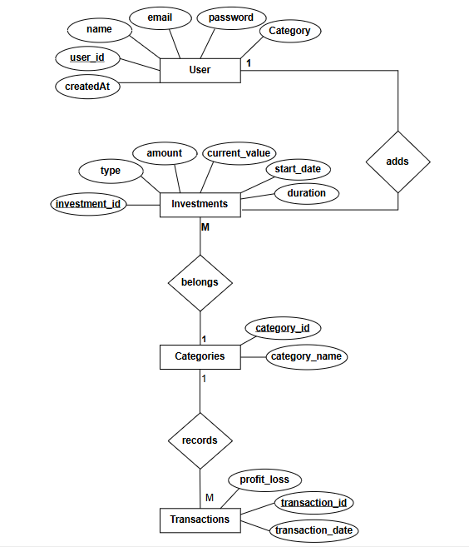
2.1 ERD

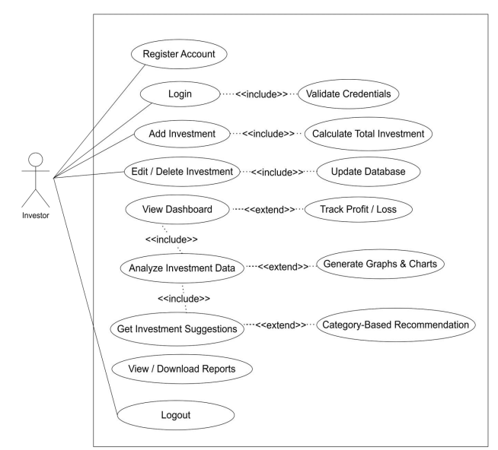
2.2 Use Case Diagram

2.3 Data Dictionary
1.User Table
Column Name | Data Type | Constraints | Description
User_id | INT | PRIMARY KEY | Unique ID for each user
User_Name | VARCHAR | NOT NULL | Full name of the user
Email | VARCHAR | UNIQUE, NOT NULL | User’s email address
Password | VARCHAR | NOT NULL | Encrypted password for authentication
Category | VARCHAR | NOT NULL | Student / Adult / Senior / Women

2.Investment Table
Column Name | Data Type | Constraints | Description
Investment_id | INT | PRIMARY KEY | Unique investment ID
User_id | INT | FOREIGN KEY, NOT NULL | Reference to user
Type | VARCHAR | NOT NULL | Investment type  (Stocks,MF,FD,Gold)
Amount | FLOAT | NOT NULL | Invested amount
Current_value | FLOAT | NOT NULL | Current market value
Start_date | DATE | NOT NULL | Investment start date
Duration | INT | NOT NULL | Investment duration

4.stocks Table
Column Name | Data Type | Constraints | Description
id | INT | PRIMARY KEY | Unique transaction ID
User_id | INT | FOREIGN KEY, NOT NULL | Reference to user
symbol | INT | FOREIGN KEY, NOT NULL | Reference to investment
quantity | INT | NOT NULL | Count of shares
Buy_price | INT | NOT NULL | Price of share

3. User Interface:

3.1 Home Page:
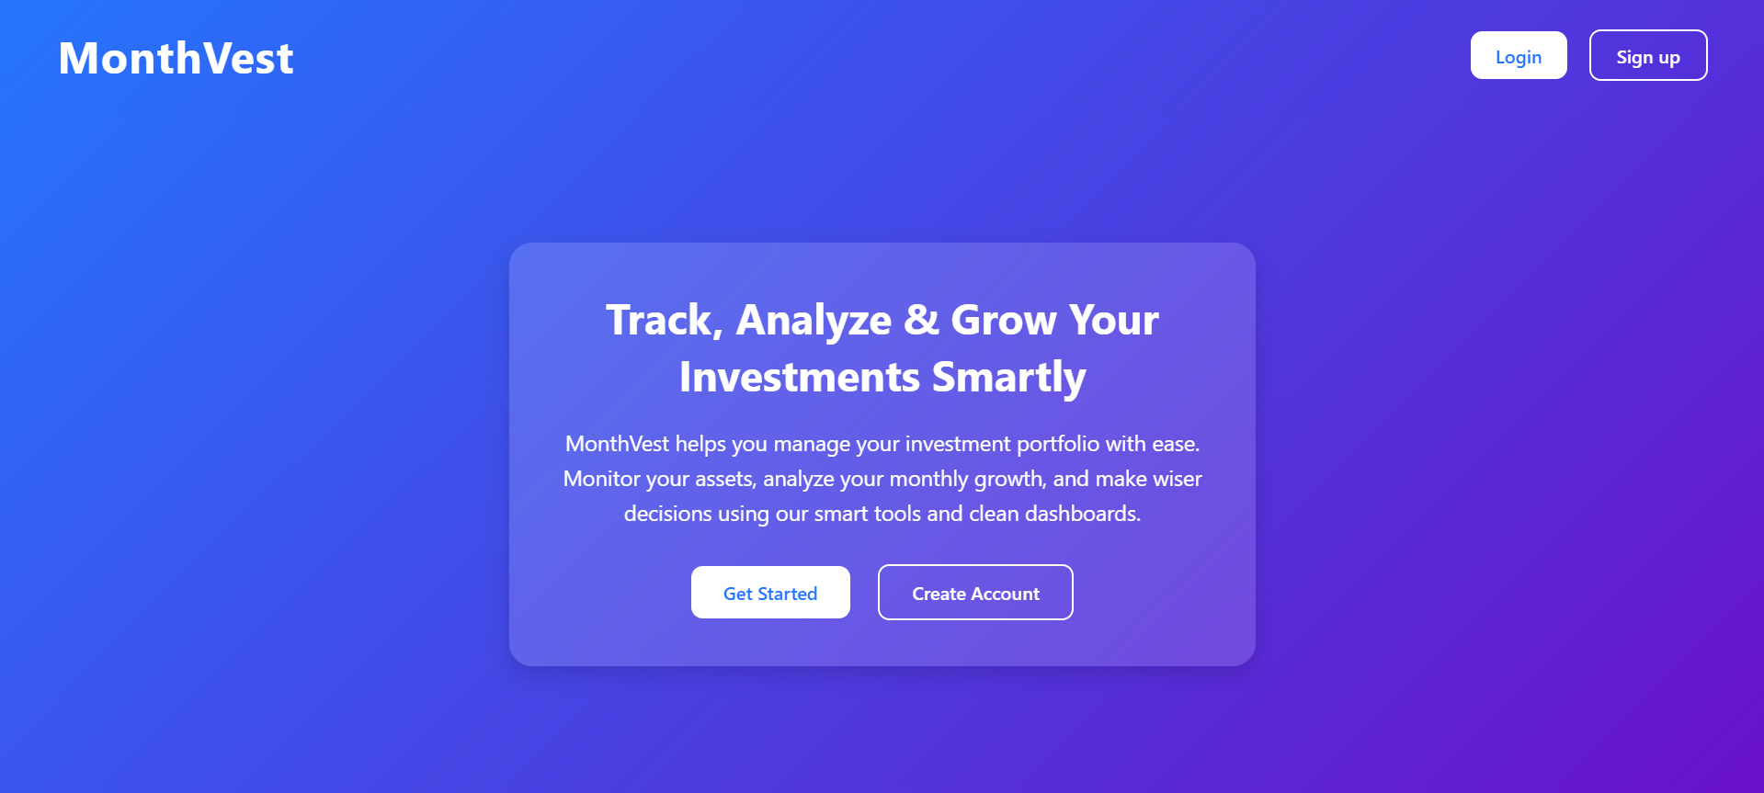

3.2.Sign up Page

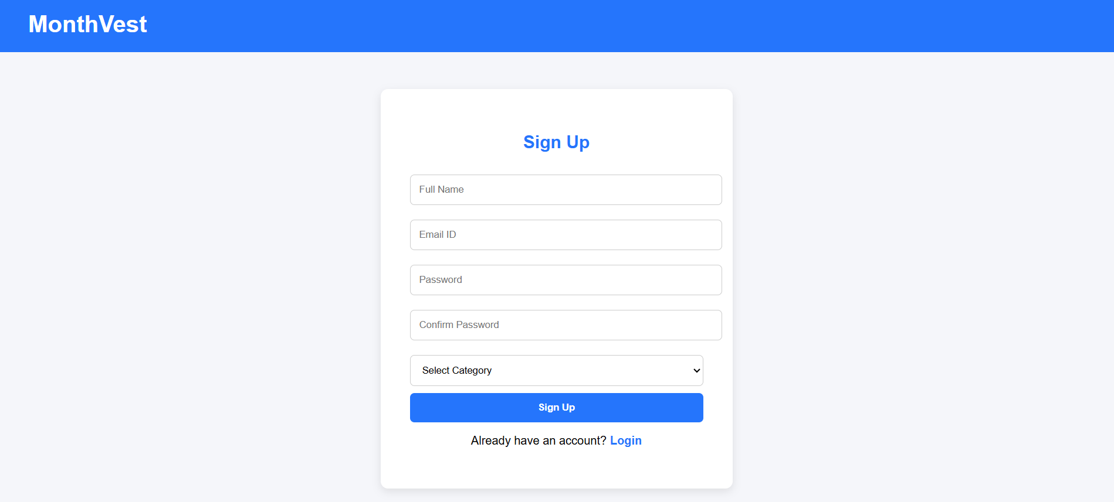

3.3.log in Page
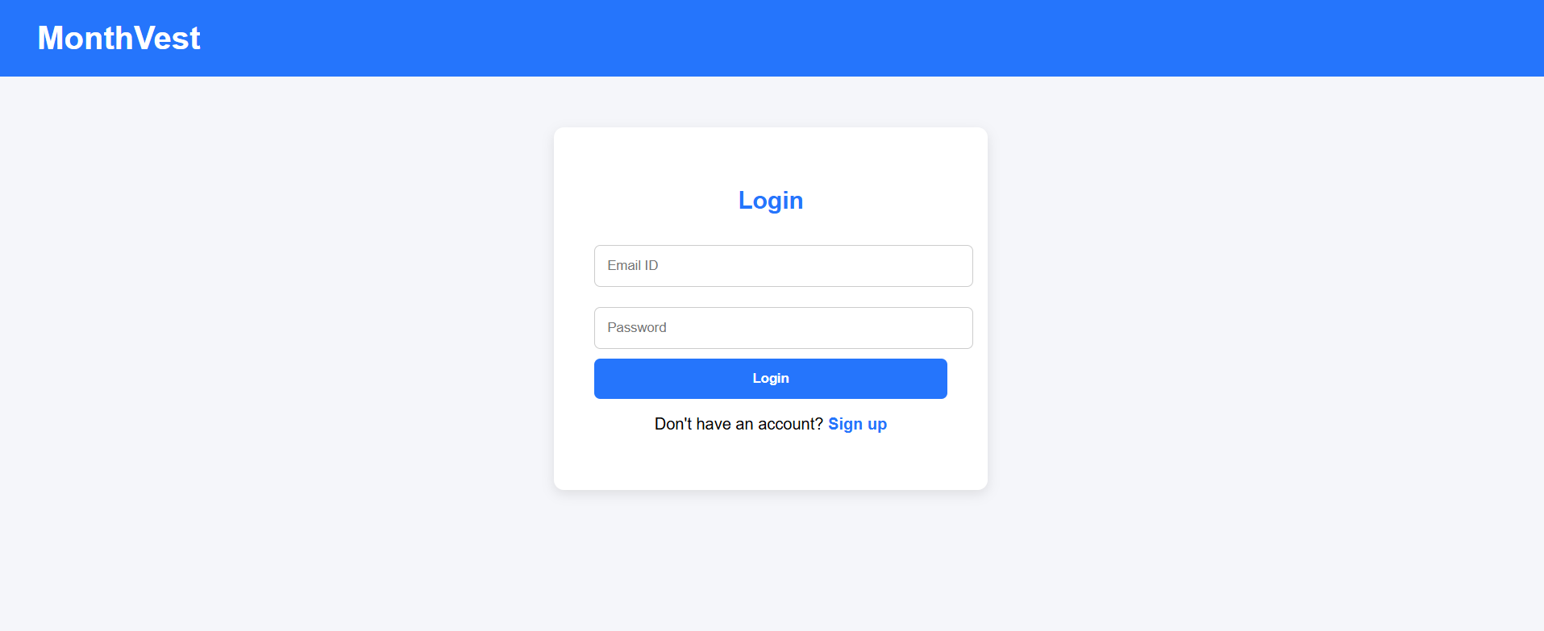

3.4 Dashboard Page
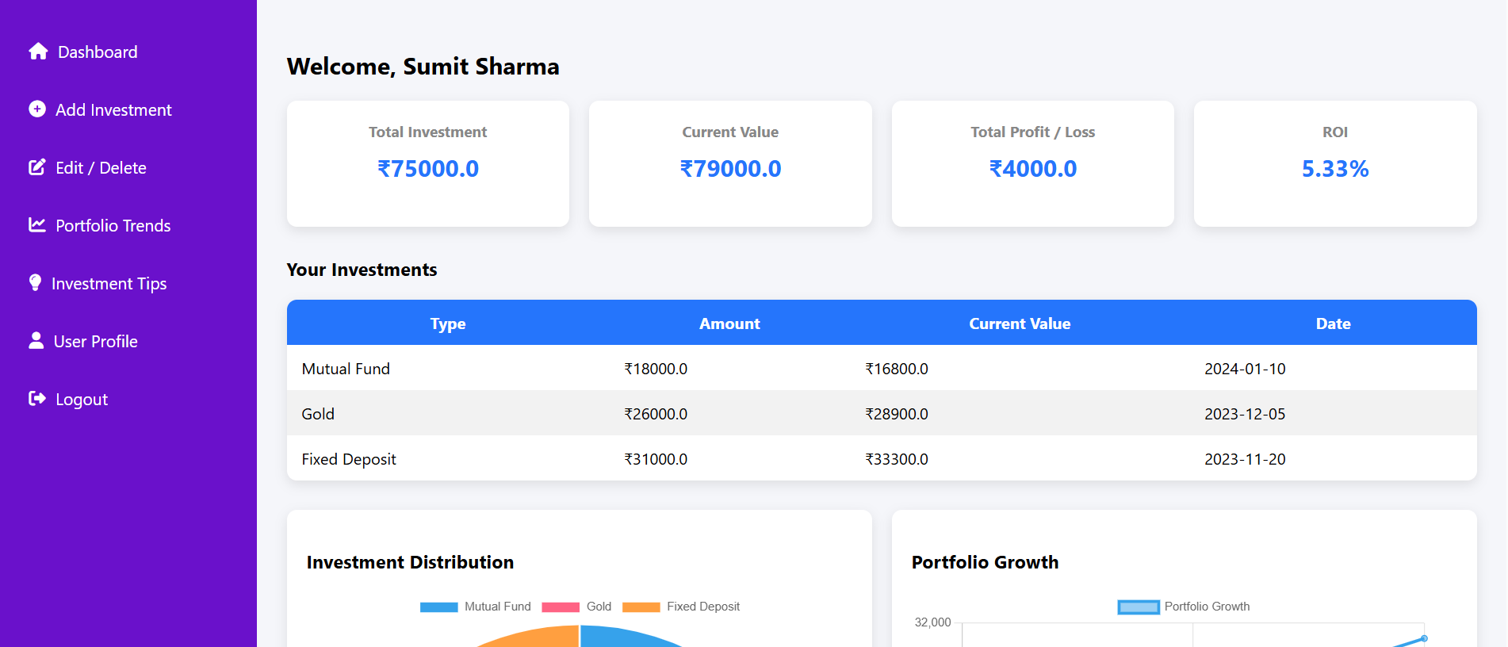

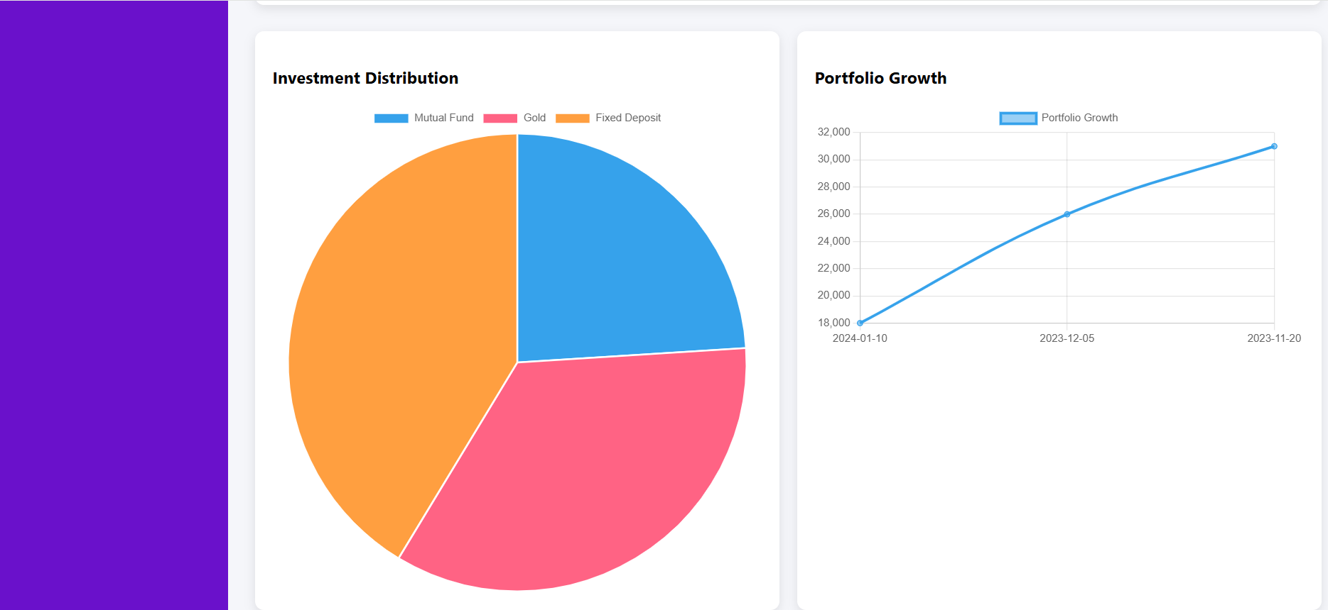

3.5 Add Investment Page
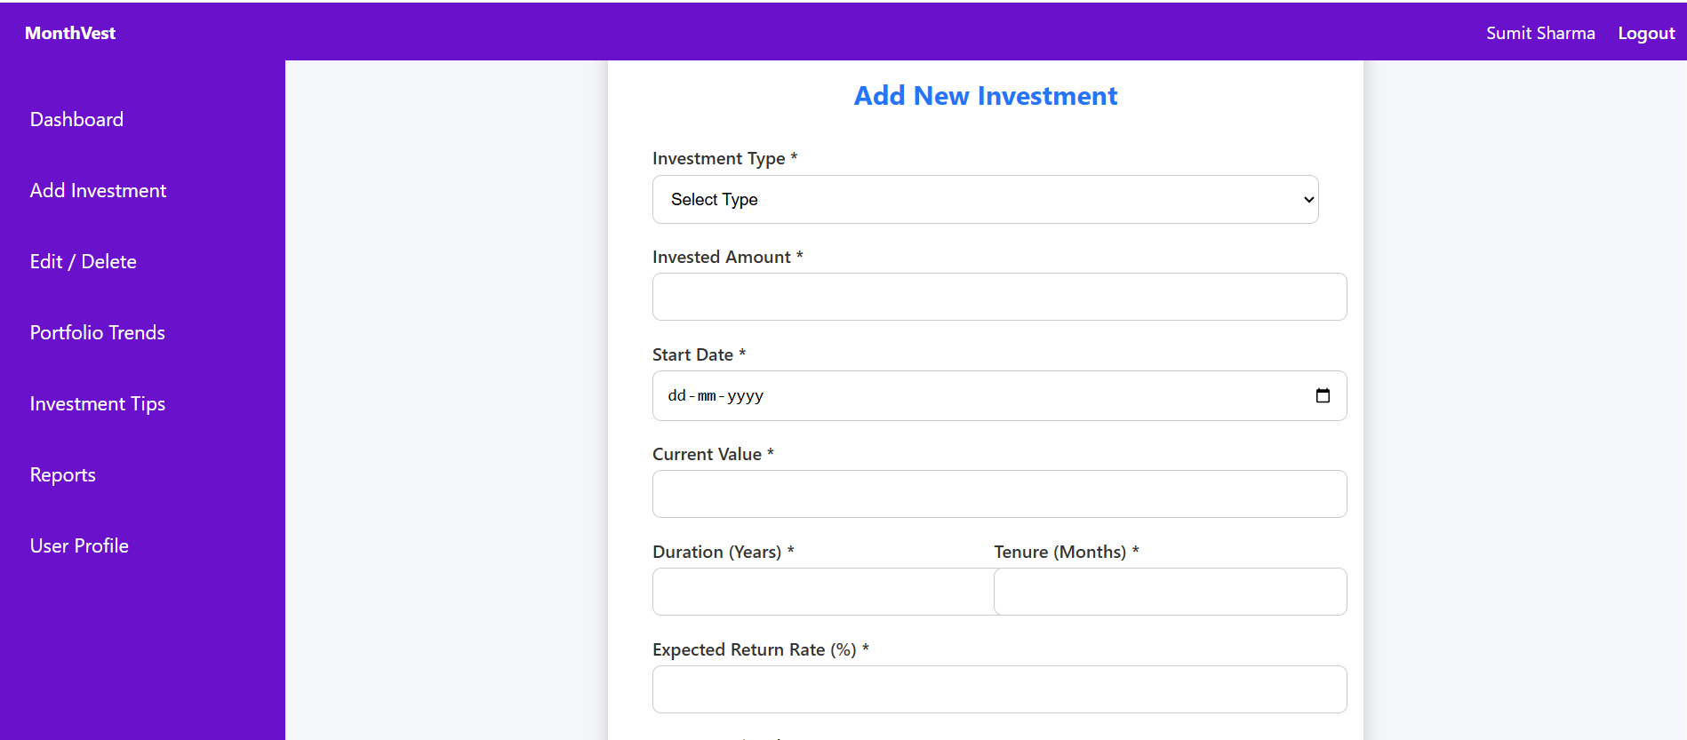

3.6 Edit / Delete Investment Page
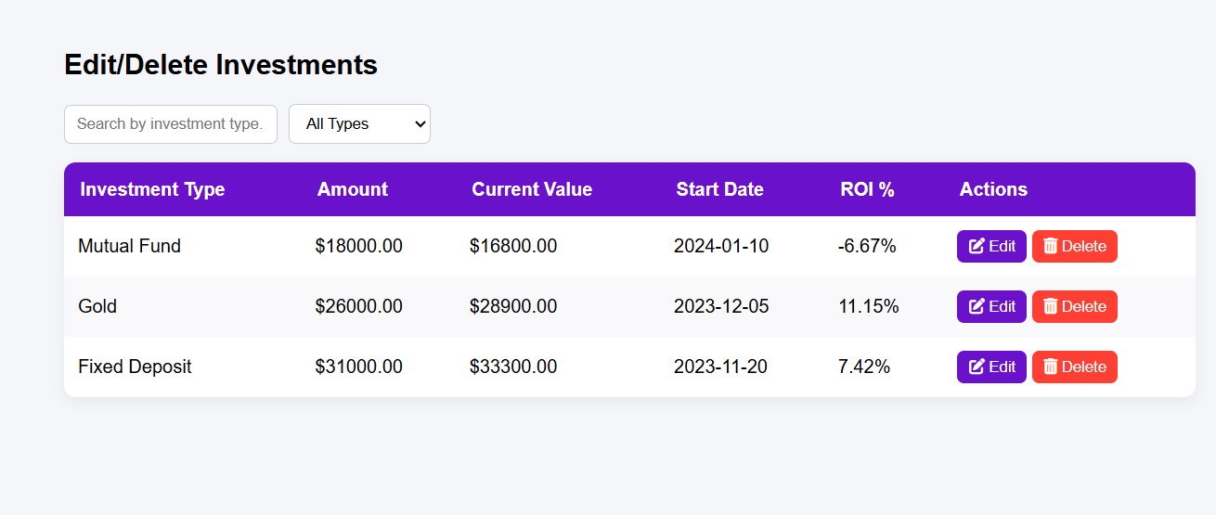

3.7 Monthly Performance Page
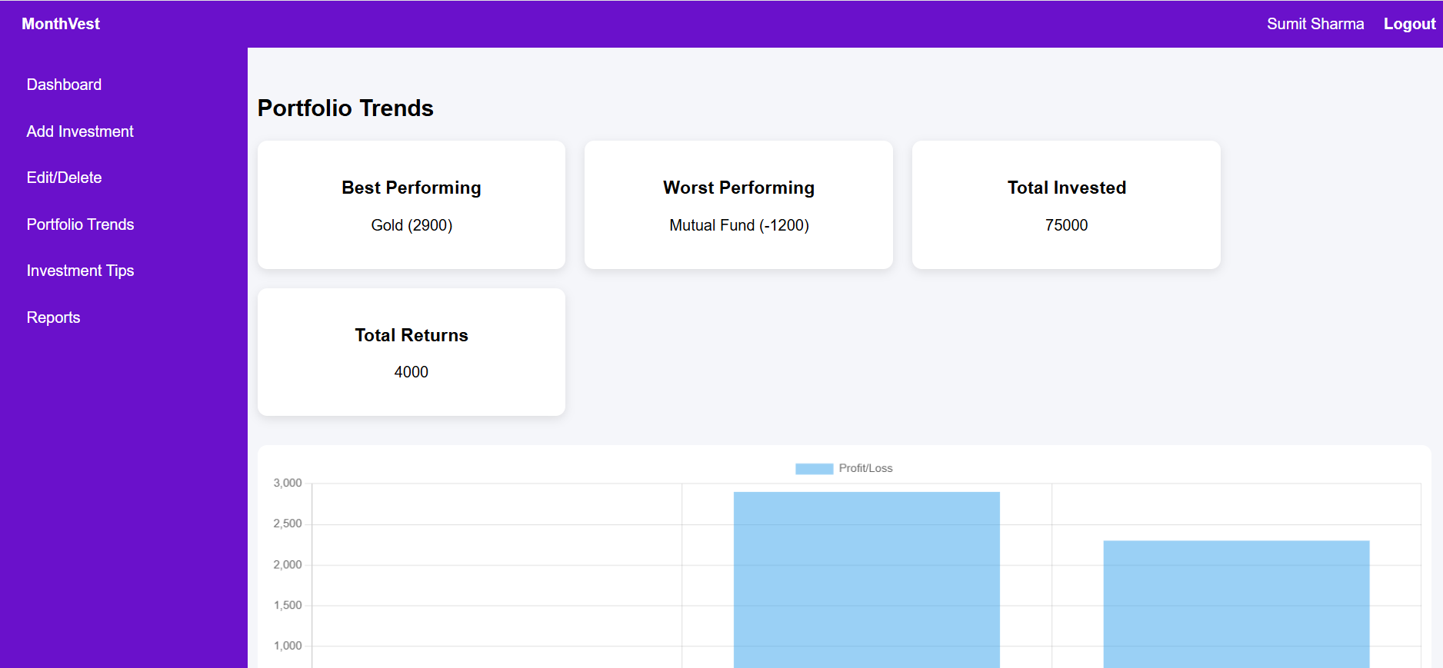
3.8.Reports
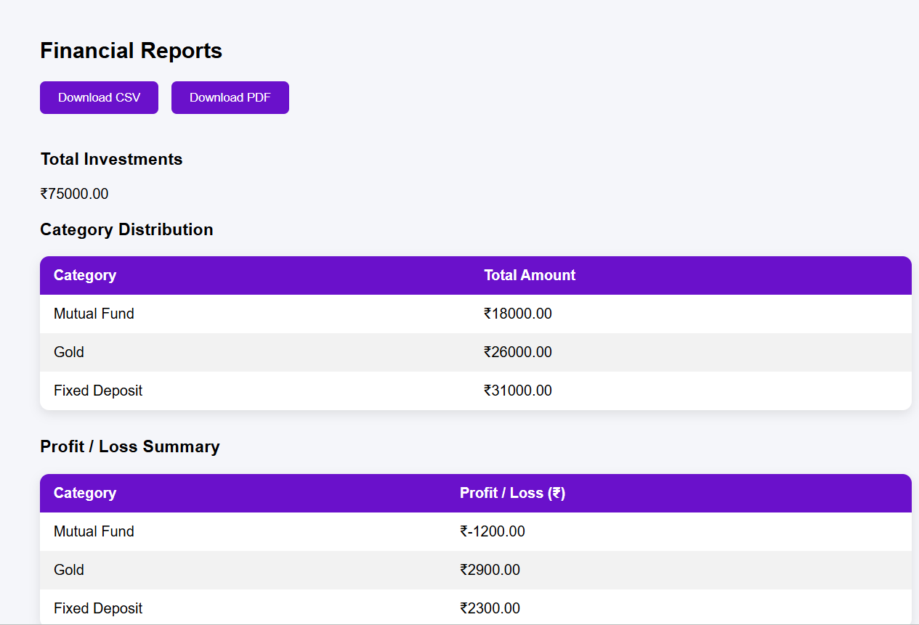

3.9 User Profile
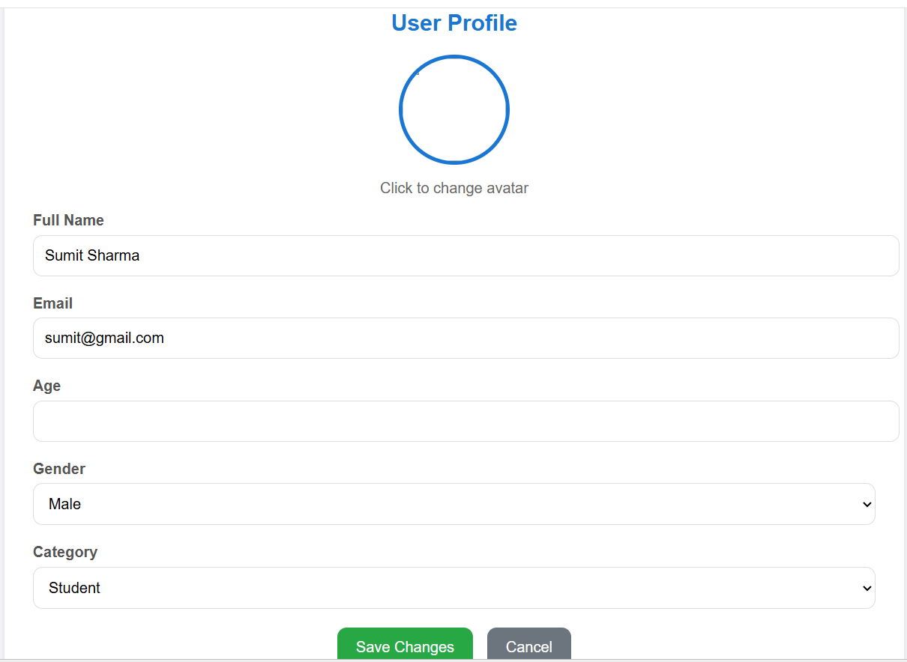

User database table
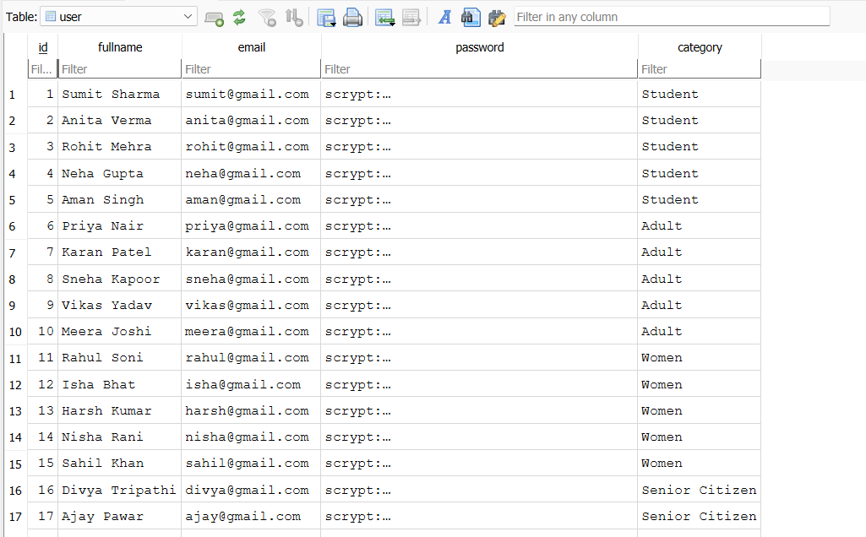

Investments database table
